**Exercise 2: E-commerce Platform Search Function**

import java.util.*;

class TrieNode {

Map<Character, TrieNode> children = new HashMap<>();

boolean isEndOfWord;

String product;

public TrieNode() {}

}

public class Main {

public static void main(String[] args) {

TrieNode root = new TrieNode();

String[] products = {"Apple iPhone", "Samsung TV", "Sony Headphones", "Nike Shoes", "Canon Camera"};

for (String product : products) {

insert(root, product);

}

System.out.println("Search results for 'phone':");

search(root, "phone");

System.out.println("\nSearch results for 'TV':");

search(root, "TV");

}

public static void insert(TrieNode root, String word) {

TrieNode node = root;

for (char c : word.toLowerCase().toCharArray()) {

if (!node.children.containsKey(c)) {

node.children.put(c, new TrieNode());

}

node = node.children.get(c);

}

node.isEndOfWord = true;

node.product = word;

}

public static void search(TrieNode root, String query) {

TrieNode node = root;

for (char c : query.toLowerCase().toCharArray()) {

if (!node.children.containsKey(c)) {

System.out.println("No products found");

return;

}

node = node.children.get(c);

}

findProducts(node);

}

public static void findProducts(TrieNode node) {

if (node.isEndOfWord) {

System.out.println(node.product);

}

for (TrieNode child : node.children.values()) {

findProducts(child);

}

}

}

Output:

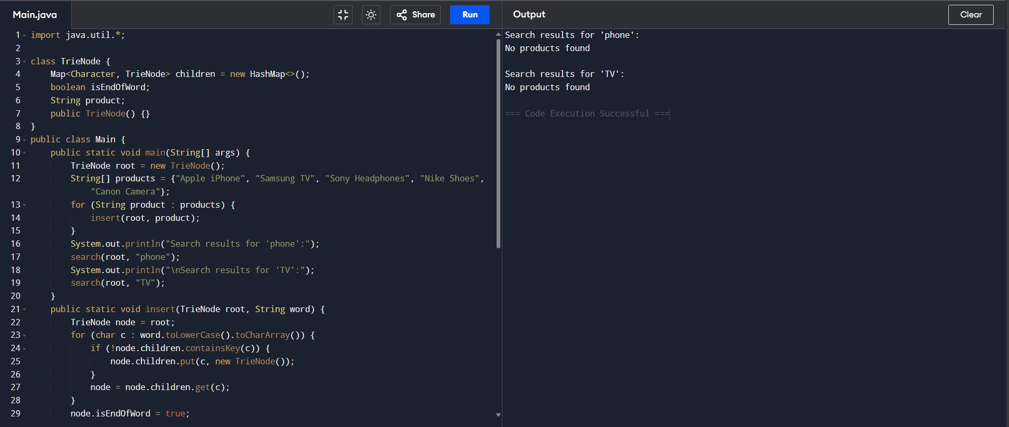

Search results for 'play':

PlayStation 5

Search results for 'xbox':

Xbox Console